**Activation function**

**What is an activation function and why to use them?**

Activation function decides, whether a neuron should be activated or not by calculating weighted sum and further adding bias with it. The purpose of the activation function is to **introduce non-linearity** into the output of a neuron.

Neural network has neurons that work in correspondence of *weight, bias* and their respective activation function. In a neural network, it will update the weights and biases of the neurons on the basis of the error at the output. This process is known as *back-propagation*. Activation functions make the back-propagation possible since the gradients are supplied along with the error to update the weights and biases.

**Why do we need Non-linear activation functions:-** A neural network without an activation function is essentially just a linear regression model. The activation function does the non-linear transformation to the input making it capable to learn and perform more complex tasks.

**Various types**

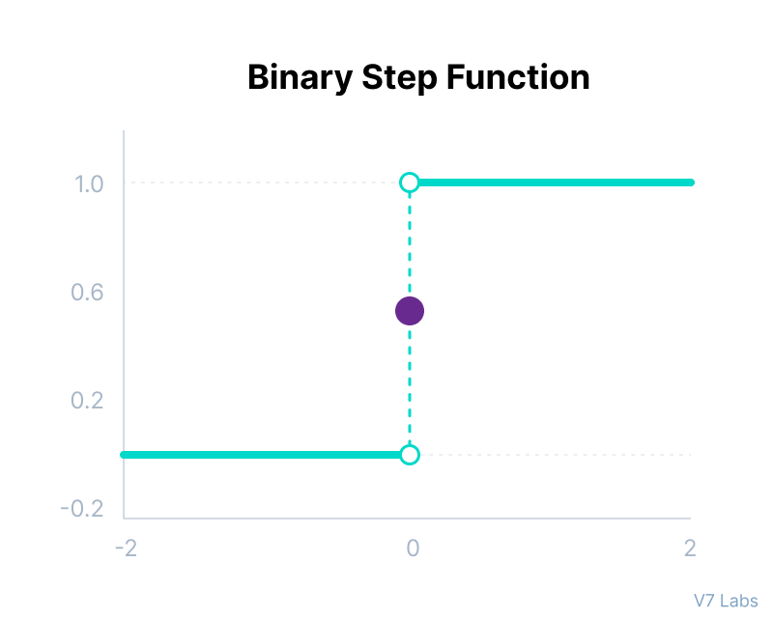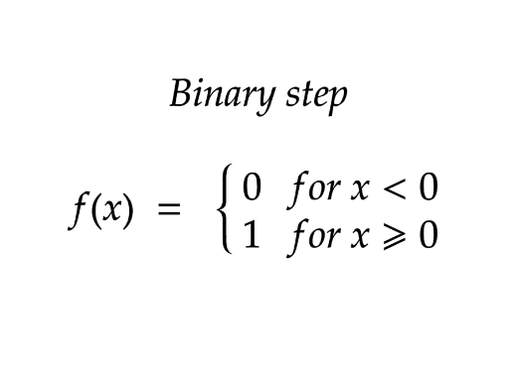

Here are some of the limitations of binary step function:

* It cannot provide multi-value outputs—for example, it cannot be used for multi-class classification problems.
* The gradient of the step function is zero, which causes a hindrance in the backpropagation process.

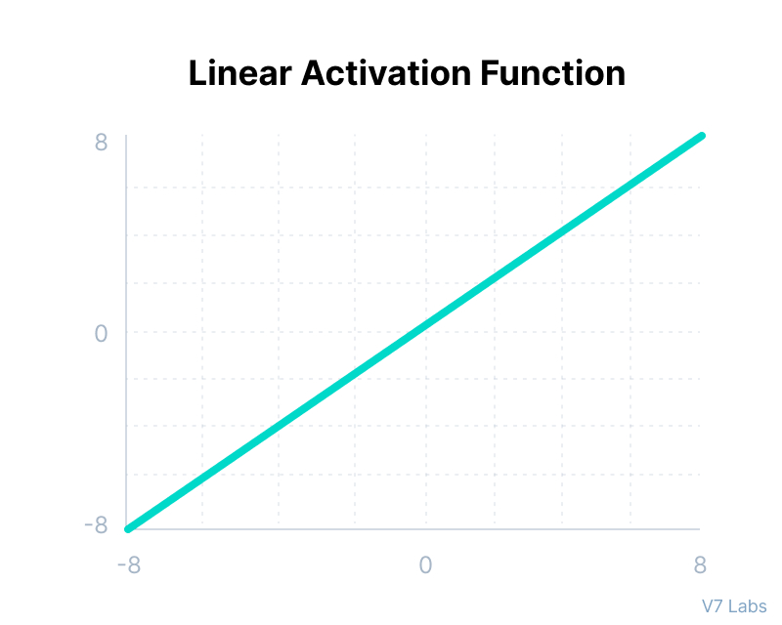

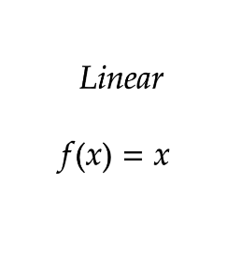

However, a linear activation function has two major problems:

* It’s not possible to use backpropagation as the derivative of the function is a constant and has no relation to the input x.
* All layers of the neural network will collapse into one if a linear activation function is used.
* 
 